Antoniette M. Guglielmo

**Museum of Modern Art, New York Word Count 1052**

The Museum of Modern Art, widely known as MoMA, located on 53rd Street between Fifth and Sixth Avenues, in Manhattan, New York, is one of the world’s premier art museums. When it opened on 7 November 1929, it was the first museum in the United States dedicated exclusively to modern art. Its founders included three philanthropists who sought to break from the traditional role of museums. Under the leadership of Alfred H. Barr, Jr. (1902-1981), its founding director, MoMA became influential in the development of international modernism through its collections and exhibitions of prominent European and American modernist artworks including painting, sculpture, film and video, photography, and architecture and design. Its headquarters, designed in the International Style, opened in 1939. MoMA has undergone several building renovations and expansions. The complex includes the *Peggy and David Rockefeller Building* housing the exhibitions galleries, and the *Lewis B. and Dorothy Cullman Education and Research Building*. The three buildings enclose the *Abby Aldrich Rockefeller Sculpture Garden.* MoMA maintains an active Department of Education, founded in 1937, and exhibits contemporary art at MoMA PS1, located in Long Island, New York.

MoMA was the brainchild of three philanthropists: Lillie Plummer Bliss (1864-1931), Abby Aldrich Rockefeller (1874-1948), and Mary Quinn Sullivan (1877-1939). Known in social circles of the day as the “daring ladies,” these progressive-minded women sought to shift the traditional role of museums and to cultivate a respect for modern art in the U.S. They chose collector and curator, Anson Conger Goodyear (1877-1964), formerly head of the board of trustees of the Knox-Albright Gallery in Buffalo, New York, to be president. Other founding trustees were Harvard University professor of art history and museum studies Paul J. Sachs (1878-1965), the founding editor of *Vanity Fair* Frank Crowninshield (1872-1947), and philanthropist Josephine Boardman Crane (1873-1972). Sachs recommended his young protégé Alfred H. Barr, Jr. for the appointment of founding director, a position Barr held until 1943.

**Buildings**

The museum’s first space was six rooms located on the twelfth floor of the Heckscher Building at 730 Fifth Avenue in Manhattan. Over the next ten years, the museum moved and expanded three times. On 10 May 1939, it opened at its current location. Modernist architects Philip L. Goodwin (1885-1958) and Edward Durrell Stone (1902-1978) designed the main building with its sleek steel and glass in the International Style. The opening was a major event drawing 6,000 people. President Franklin D. Roosevelt delivered the opening address via radio from the White House. That year Nelson Rockefeller (1908-1979) became the museum’s president. Nelson’s brother, David Rockefeller (1915-), joined the museum's board of trustees in 1948 and became president in 1958. In the 1950s and 1960s, the museum underwent additional expansions by Philip Johnson (1906-2005), who also designed the *Abby Aldrich Rockefeller Sculpture Garden.* Another renovation in 1984 by Cesar Pelli doubled the Museum’s gallery space. In 1997, Yoshio Taniguchi won the competition to renovate the headquarters. This renovation, which occurred in the early 2000s, created 63,000 square feet of new and redesigned space. The *Peggy and David Rockefeller Building* to the west houses the main exhibitions galleries, and the *Lewis B. and Dorothy Cullman Education and Research Building* to the east houses classrooms, auditoriums, workshops for teachers, and the libraries and archives. These renovated buildings enclose the enlarged *Abby Aldrich Rockefeller Sculpture Garden.*

**Collections**

MoMA opened with an original gift of eight prints and one drawing given by Sachs. The founders primarily conceived of MoMA as a place for exhibiting contemporary art rather than a collecting institution. MoMA had planned to deaccession artworks to remain focused on avant-garde art, but in 1952 changed course and established a permanent collection. An important portion of the collection came from Bliss’s bequest to the Museum which included Paul Cézanne’s *The Bather* (c. 1885), along with artworks by Honoré Daumier, Edgar Degas, André Derain, Henri Matisse, Amedeo Modigliani, Pablo Picasso, Odilon Redon, Pierre-August Renoir, Henri Rousseau, Georges Seurat, and Henri de Toulouse-Lautrec. Bliss stipulated that funds from deaccessioned art in her collection go towards new acquisitions. She also left MoMA with the challenge to raise $1 million in order to endow the bequest, which the museum officially acquired in 1934 after raising $600,000. Over time, the museum continued to acquire a wide-range of influential European and American artworks. According to its website, MoMA has a collection of “over 150,000 paintings, sculptures, drawings, prints, photographs, architectural models and drawings, and design objects. MoMA also owns approximately 22,000 films and four million film stills, and MoMA's Library and Archives…hold over 300,000 books, artist books, and periodicals, and extensive individual files on more than 70,000 artists.”

**Education**

MoMA established a Department of Education in 1937, with Victor D’Amico serving as its founding director until 1969. D’Amico was a progressive who championed innovation, creativity, imagination, and a democratic approach to art education. He developed extensive outreach programs. Among these were classes for military servicepersons at the War Veteran’s Art Center, which transitioned to the People’s Art Center in 1948, as well as circulating exhibitions at New York City high schools. From 1942 to 1969, he oversaw the Children’s Art Carnivals—spaces for children only— that travelled internationally. He started summer programs on the Art Barge in Long Island and published a series of instructional books for home study on a variety of artistic crafts. D’Amico also produced an educational television series (1952-1953) for children called “Through the Enchanted Gate.” MoMA continues an active educational mission offering a variety of programs for general and targeted audiences to appreciate and understand modern and contemporary art.

In January 2000, MoMA formalized its affiliation with P.S. 1 Contemporary Art, a collaboration resulting in the formation of MoMA PS1. This is an exhibition space housed in a renovated school building in Long Island, New York. MoMA PS1 exhibits provocative and experimental contemporary art from around the world. It has featured artists' retrospectives, site-specific installations, historical surveys, and performing arts programs.

**References and Further Reading**

Bee, H. and Elligott, M. (eds.) (2004) *Art in Our Time: A Chronicle of the Museum of Modern Art*. New York: The Museum of Modern Art.

Lowry, G. (2009) *The Museum of Modern Art in this Century*. New York: The Museum of Modern Art.

Staniszewski, M.A. (1998) *The* *Power of Display: A History of Exhibition Installations at the Museum of Modern Art*. Cambridge and London: MIT Press.

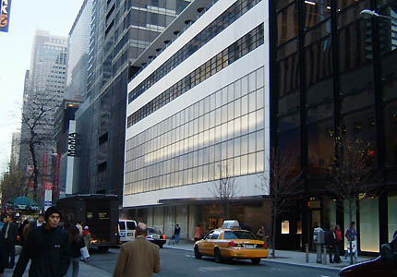

Museum of Modern Art, 11 West 53rd Street, New York NY 10019

Edward Durrell Stone and Philip Goodwin 1939; Yoshio Taniguchi 2004

<http://www.galinsky.com/buildings/moma/>

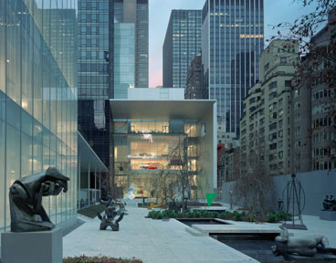

New exhibition building designed by Yoshio Taniguchi, 2004 [PA]. © Timothy Hursley 2004

<http://www.moma.org/interactives/exhibitions/2009/momastarts/>